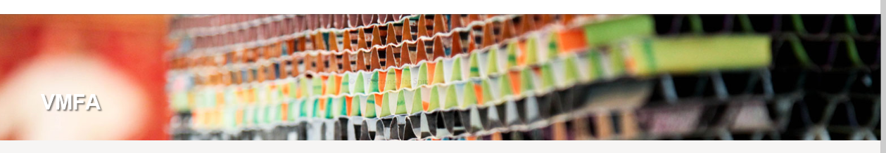
CONTRACTING OPPORTUNTIES
TEXT
Contractors submitting proposals understand and agree to abide by the Safety and Security Conditions for Contractors. Click here Safety & Security Conditions for VMFA Contractors November 2014.pdf for the Safety and Security Conditions for Contractors
Depending on the scope of work, other special terms and conditions may apply. Contact VMFA’s Health and Safety Coordinator al.timpano@vmfa.museum for any questions concerning the Safety and Security Conditions for Contractors.

