**Here is the information for the business cards needed:**

FORMAT EXAMPLE:

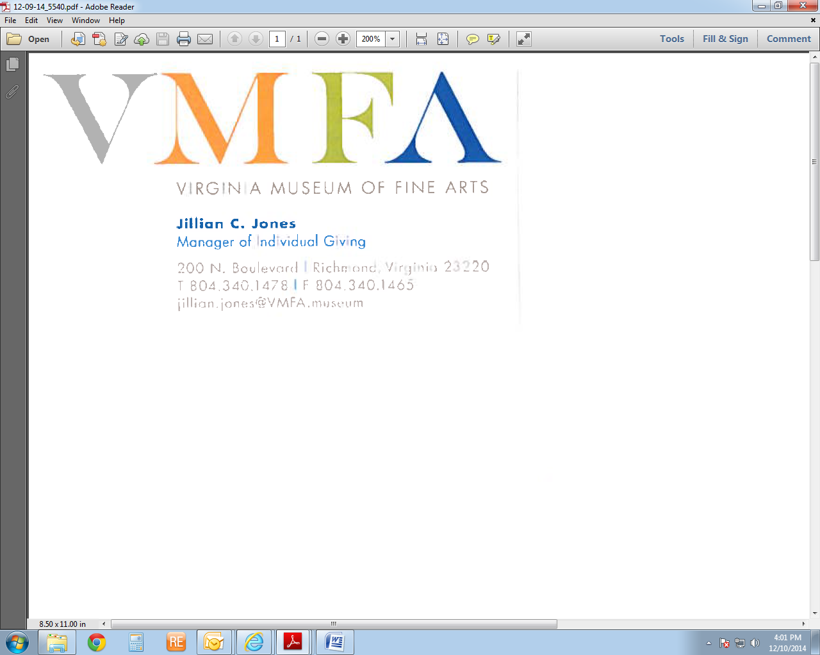

**First Name Last Name**

**Official Role and Department**

**200 N. Boulevard | Richmond, Virginia 23220**

**Telephone/Fax Number**

**Email Address**