Publicity Images for Evans 360º
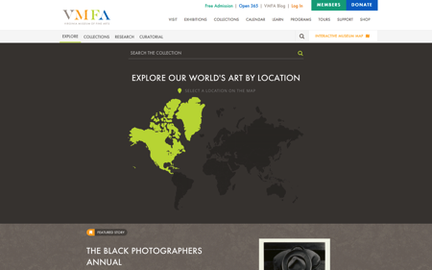  Collections Search Landing Page |  | 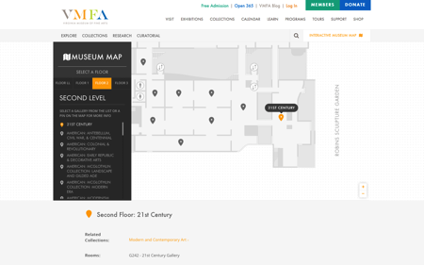  Interactive Museum Map
The Permanent Collection Introduction Page |  | Learn Portal Resource Center Landing Page
Mobile Collections Search  Landing Page | 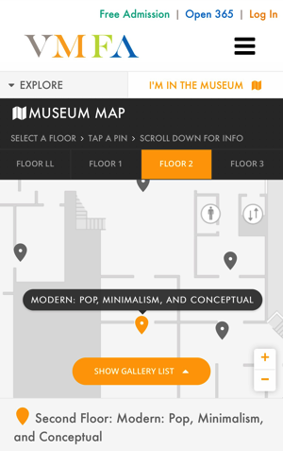  Mobile Interactive Museum Map |  | Mobile Resource Center  Landing Page

