**FOR IMMEDIATE RELEASE**

February 20, 2025

**The Virginia Museum of Fine Arts Awards Nearly $160,000 to 2025–26 Fellowship Recipients**

Twenty-four Commonwealth residents named Visual Arts Fellowship recipients

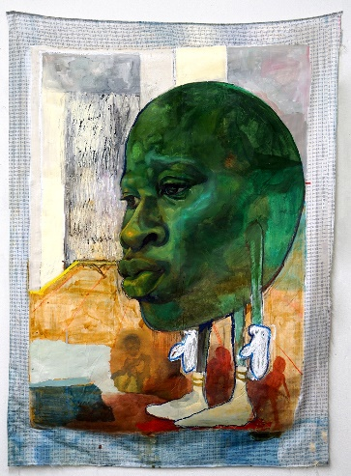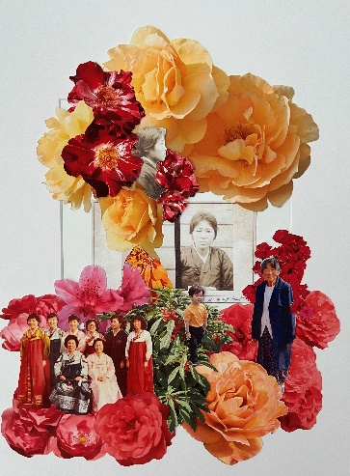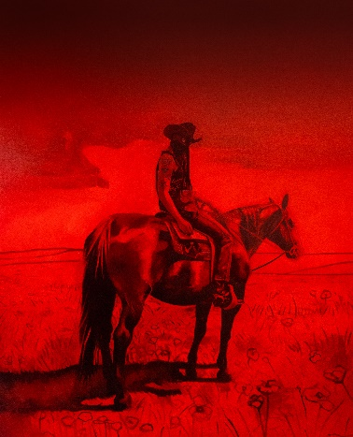

Works of art by VMFA’s 2025–26 Visual Arts Fellowship award recipients (left to right): *All I Ever Wanted Was to Kiss the Sun*, 2023, by Andrew

Norris; *Peanut Head*, 2022, by Kevin Hopkins; and 사람이꽃보다아름다워 (*people are more beautiful than flowers)*, 2022, by Adele Yiseol Kenworthy

**Richmond, VA —** The Virginia Museum of Fine Arts (VMFA) is pleased to announce the 2025–26 recipients of its Visual Arts Fellowship awards. This year, 24 professional artists and graduate and undergraduate students have received awards — totaling nearly $160,000 — to further their artistic careers.

Established through a generous contribution made by the late John Lee Pratt of Fredericksburg, Virginia, in 1940, VMFA’s Visual Arts Fellowship Program marks its 85th anniversary this year. As a vital source of funding for the visual arts and art history, the museum has awarded more than $6 million in fellowship awards to Virginians since its inception.

“The Virginia Museum of Fine Arts Fellowship Program is proud to support professional and student artists working across the Commonwealth,” said Director and CEO Alex Nyerges. “Each year, through one of the largest fellowship programs of its kind in the United States, we recognize and provide transformative financial resources and exhibition opportunities to help advance the artistic careers of talented Virginians. This effort is a core part of the museum’s mission.”

Recipients of VMFA’s Visual Arts Fellowship awards must be residents of the Commonwealth of Virginia and may use the money they receive as desired, including for education and studio investments.

Museum curators and working artists serve as jurors to select the award recipients. This year, Miranda Lash, the Ellen Bruss Senior Curator at the Museum of Contemporary Art Denver (Colorado), served as the professional-level juror. The graduate art history juror was Shawnya Harris, the Deputy Director of Curatorial and Academic Affairs and the Larry D. and Brenda A. Thompson Curator of African American and African Diasporic Art at the Georgia Museum of Art (Athens). Sara Woodbury, Curator of Art at the Barry Art Museum (Norfolk, Virginia), served as the juror for the graduate and undergraduate visual arts categories.

VMFA has awarded 12 professional-level fellowships of $8,000 each to the following artists:

* **Sam Blanchard** (Blacksburg), sculpture
* **Zach Duer** (Christiansburg), new and emerging media
* **Julie Grosche** (North Chesterfield), film and video
* **HH Hiaasen** (Richmond), mixed media
* **Min-Haeng Kang** (Richmond), crafts
* **Jeffrey Kenney** (Linden), painting
* **Adele Yiseol Kenworthy** (Vienna), new and emerging media
* **Pedro Ledesma III** (Arlington), photography
* **Andrew Norris** (Richmond), painting
* **Benjamin Rinehardt** (Richmond), film and video
* **Eric Standley** (Blacksburg), mixed media
* **Paul Thulin-Jimenez** (Richmond), photography

Five graduate students have been awarded $6,000 each:

* **Erin Ehren** (Richmond), sculpture, Virginia Commonwealth University
* **Jolinna Li** (Charlottesville), film and video, University of Virginia
* **Alexis Torres Marroquín** (Richmond), new and emerging media, Virginia Commonwealth University
* **Nathaniel Newcomb** (Richmond), crafts, Virginia Commonwealth University
* **Lizzie Rivard** (Charlottesville), art history, University of Virginia

Undergraduate fellowships of $4,000 each have been awarded to six students:

* **Ashley Davis** (New Kent), film and video, Virginia Commonwealth University
* **Grace Heinzelmann** (Vienna), new and emerging media, University of Virginia
* **Theodore Mayberry** (Norfolk), mixed media, Old Dominion University
* **Kenneth Nguyen** (Herndon), film and video, University of Virginia
* **Sirena Pearl** (Arlington), painting, Virginia Commonwealth University
* **Connie Wang** (Fairfax), painting, Virginia Commonwealth University

This year’s recipient of the Cy Twombly Graduate Fellowship award, supported by the McClintic Endowment, is Richmond resident **Kevin Hopkins**, who is studying painting at Virginia Commonwealth University.

Offered through the VMFA Statewide Program, Visual Arts Fellowship awards are still largely funded through the Pratt Endowment and the J. Warwick McClintic Jr. Fellowship Fund. In addition to providing financial awards to all recipients, VMFA exhibits works by past fellowship winners in VMFA’s Amuse Restaurant, Claiborne Robertson Room and Pauley Center Galleries, as well as at the Richmond International Airport. Several past and present fellowship recipients have also shown their work in the galleries of the Workhouse Arts Center in Lorton and the Capital One Commons in Richmond.

For more information about the Virginia Museum of Fine Arts and its Visual Arts Fellowship Program, visit [www.VMFA.museum](http://www.VMFA.museum).

# # #

**About the Virginia Museum of Fine Arts**  
The Virginia Museum of Fine Arts in Richmond, Virginia, is one of the largest comprehensive art museums in the United States. VMFA, which opened in 1936, is a state agency and privately endowed educational institution. Its purpose is to collect, preserve, exhibit and interpret art, and to encourage the study of the arts. Through the Office of Statewide Partnerships Program, the museum offers curated exhibitions, arts-related audiovisual programs, symposia, lectures, conferences, and workshops by visual and performing artists. In addition to presenting a wide array of special exhibitions, the museum provides visitors with the opportunity to experience a global collection of art that spans more than 6,000 years. VMFA’s permanent holdings encompass more than 50,000 artworks, including the largest public collection of Fabergé outside of Russia, the finest collection of Art Nouveau outside of Paris and one of the nation’s finest collections of American art. VMFA is also home to important collections of Chinese art, English silver, French Impressionist, Post-Impressionist, British sporting and modern and contemporary art, as well as renowned South Asian, Himalayan and African art. In May 2010, VMFA opened the James W. and Frances G. McGlothlin Wing I after a transformative expansion, previously the largest in its history. A new expansion, the McGlothlin Wing II, is planned to open in 2028. Comprising more than 170,000 square feet, it will be the largest expansion in the museum’s history and will make VMFA the fourth largest comprehensive art museum in the United States.

**Recently named one of the 20 best art museums in the U.S. by *The Washington Post*, the Virginia Museum of Fine Arts is the only art museum in the United States open 365 days a year with free general admission. For additional information, telephone (804) 340-1400 or visit** [**www.VMFA.museum**](https://www.vmfa.museum)**.**

**Media Contacts**

Jan Hatchette | (804) 204-2721 | [jan.hatchette@vmfa.museum](mailto:jan.hatchette@VMFA.museum?subject=jan.hatchette@VMFA.museum%20)Amy Peck | (804) 773-1791 | [amy.peck@vmfa.museum](mailto:amy.peck@vmfa.museum)

Camryn Royal | (804) 204-2717 | [camryn.royal@vmfa.museum](mailto:camryn.royal@vmfa.museum)

200 N. Arthur Ashe Blvd., Richmond, VA 23220